

Semester One Examination, 2022

Question/Answer booklet

MATHEMATICS SPECIALIST
UNIT 3

Section One:

Calculator-free

Your Name

Your Teacher’s Name

Time allowed for this section
Reading time before commencing work: five minutes
Working time: fifty minutes

Materials required/recommended for this section
To be provided by the supervisor
This Question/Answer booklet
Formula sheet

To be provided by the candidate
Standard items: pens (blue/black preferred), pencils (including coloured), sharpener, correction fluid/tape, eraser, ruler, highlighters

Special items: nil

Important note to candidates
No other items may be taken into the examination room. It is your responsibility to ensure that you do not have any unauthorised material. If you have any unauthorised material with you, hand it to the supervisor before reading any further.
Question | Mark | Max | Question | Mark | Max
1 |  |  | 5
2 |  |  | 6
3 |  |  | 7
4 |  |  | 8

Structure of this paper

Section | Number of questions available | Number of questions to be answered | Working time (minutes) | Marks available | Percentage of examination
Section One:  Calculator-free | 8 | 8 | 50 | 52 | 35
Section Two:  Calculator-assumed | 14 | 14 | 100 | 97 | 65
 |  |  |  | Total | 100

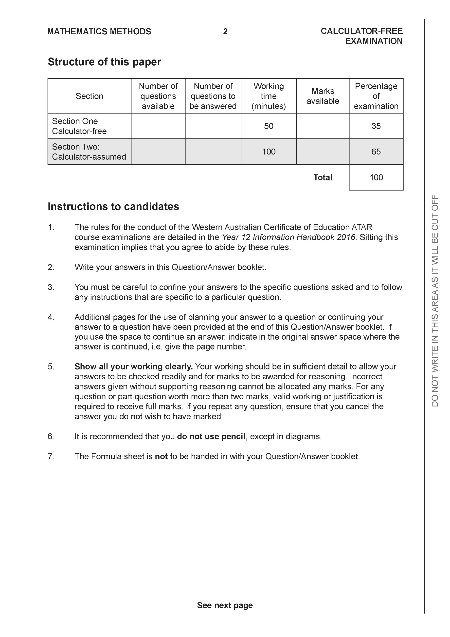

Section One: Calculator-free (52 Marks)

This section has eight (8) questions. Answer all questions. Write your answers in the spaces provided.

Spare pages are included at the end of this booklet. They can be used for planning your responses and/or as additional space if required to continue an answer.
● Planning: If you use the spare pages for planning, indicate this clearly at the top of the page.
● Continuing an answer: If you need to use the space to continue an answer, indicate in the original answer space where the answer is continued, i.e. give the page number. Fill in the number of the question that you are continuing to answer at the top of the page.

Working time: 50 minutes.

Question 1 (4 marks)

Consider the complex number as plotted on the complex plane below.

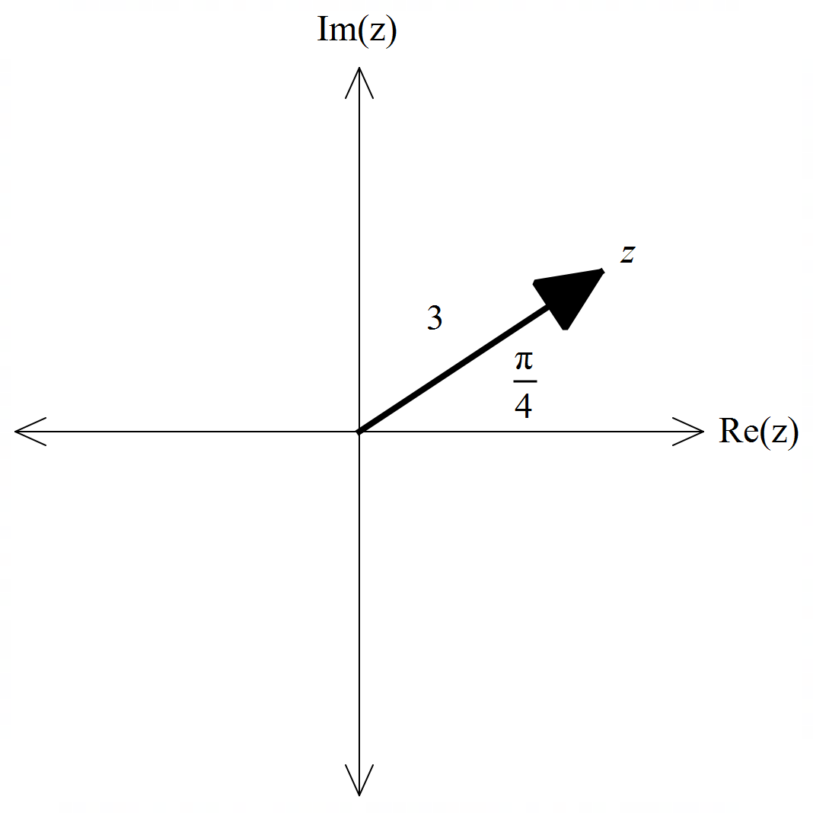

- Determine the exact value of and plot on the axes above. (2 marks)

- Determine the exact value of. (2 marks)
Question 2 (8 marks)

Consider the functions with domains shown in the graphs below.
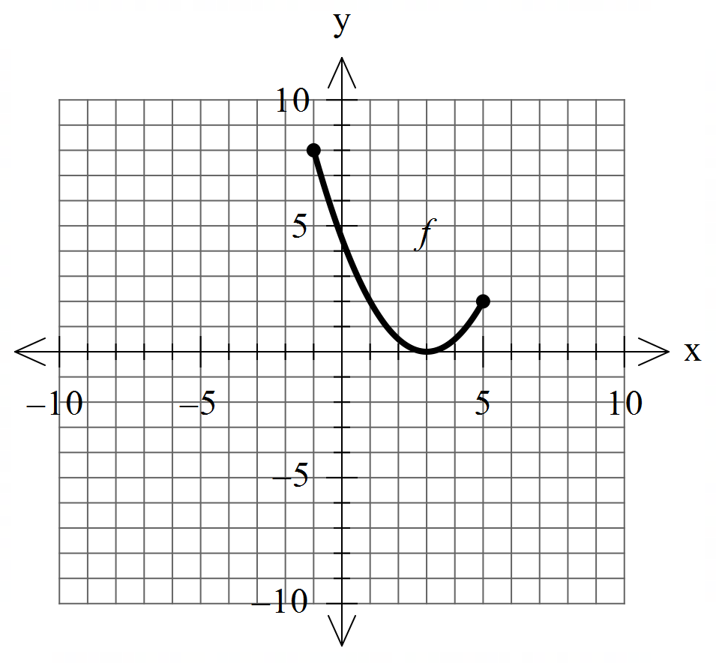  - Sketch the inverse functions above.  If they exist. (2 marks) | 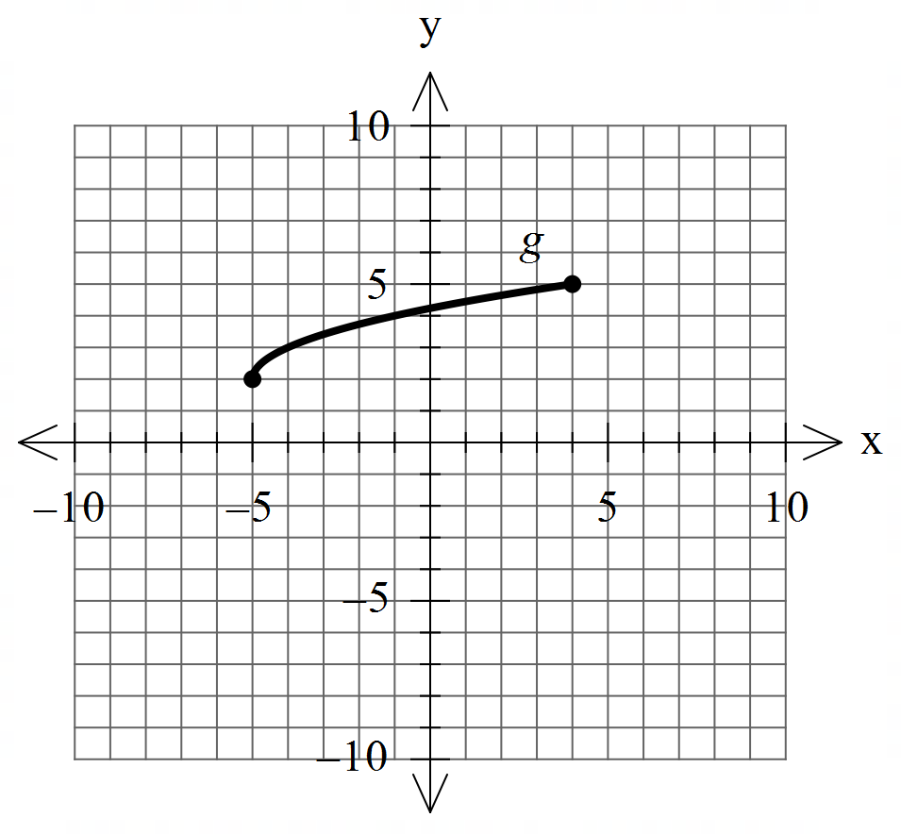
- Which of the following exist over natural domains, , ? Explain.
State the natural domain and corresponding ranges for those that exist. (3 marks)

- The rule for is . State the inverse rule and its domain. (3 marks)

Question 3 (5 marks)

Consider the function .
Plot on the axes below labelling intercepts and asymptotes.

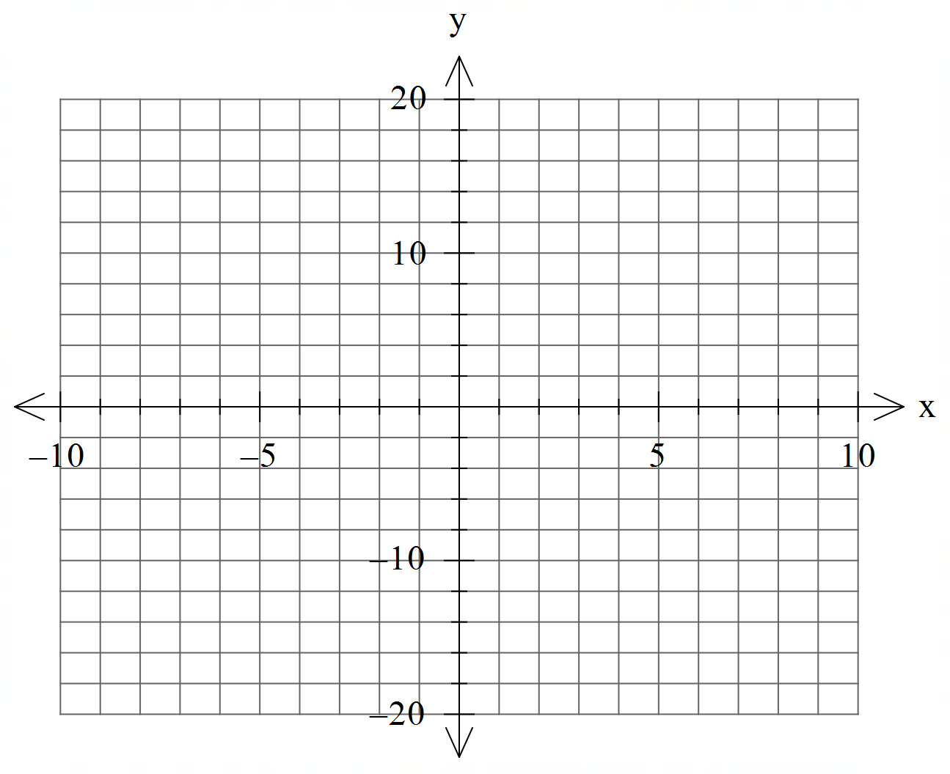

Question 4 (8 marks)

Consider the polynomial for the complex variable .

- Given that , determine a quadratic factor of . (3 marks)

- If , determine all solutions to . (2 marks)

- can be expressed as where are real integers. Determine the values of . (3 marks)
Question 5 (7 marks)

Consider the function .
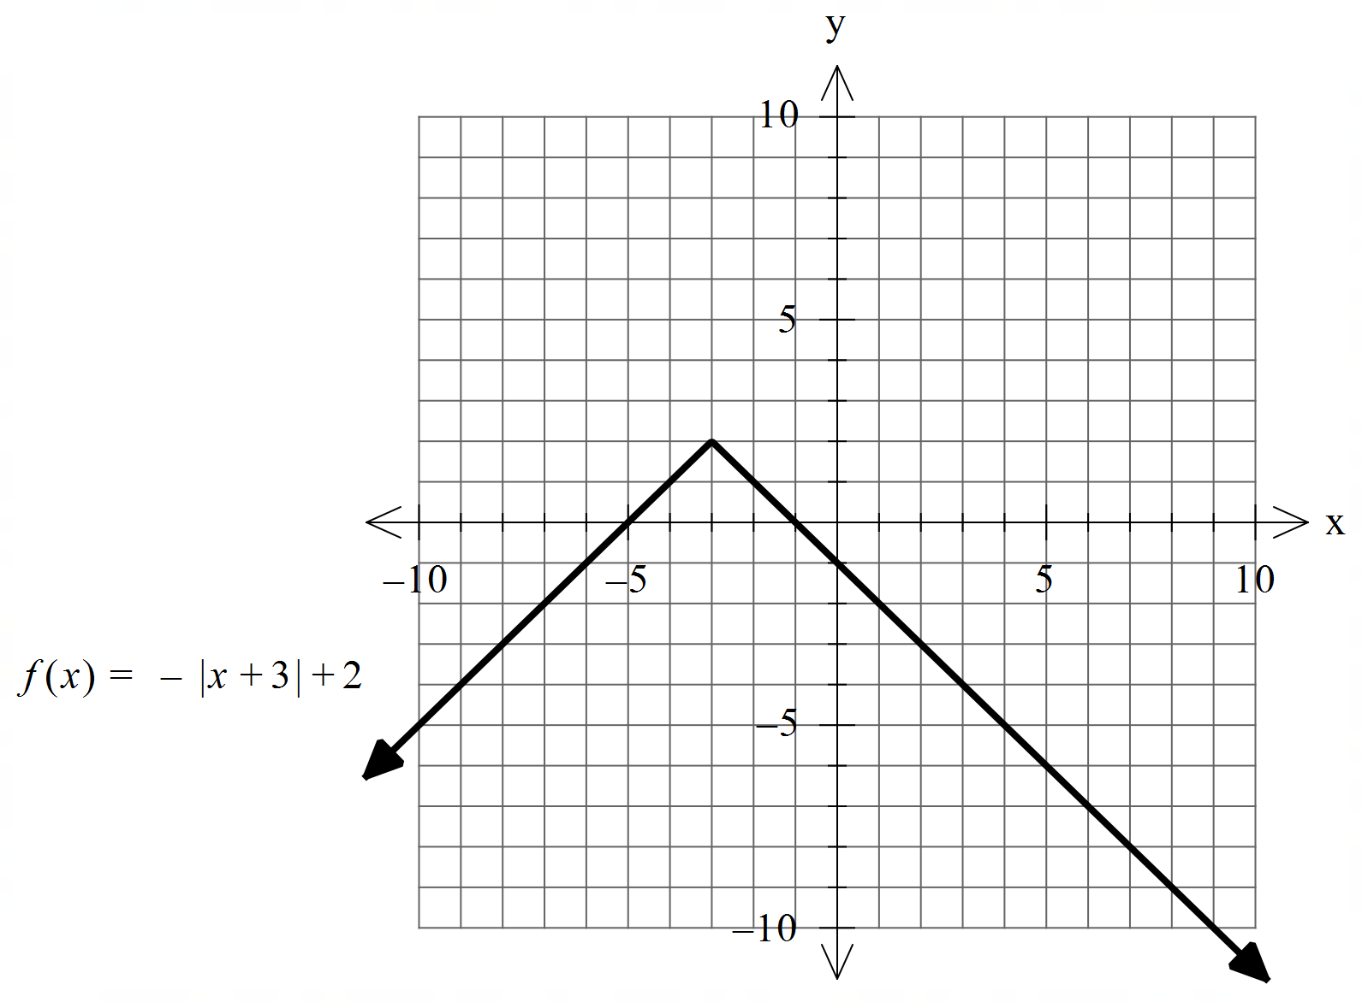

- Sketch on the axes below, labeling important features. (4 marks)
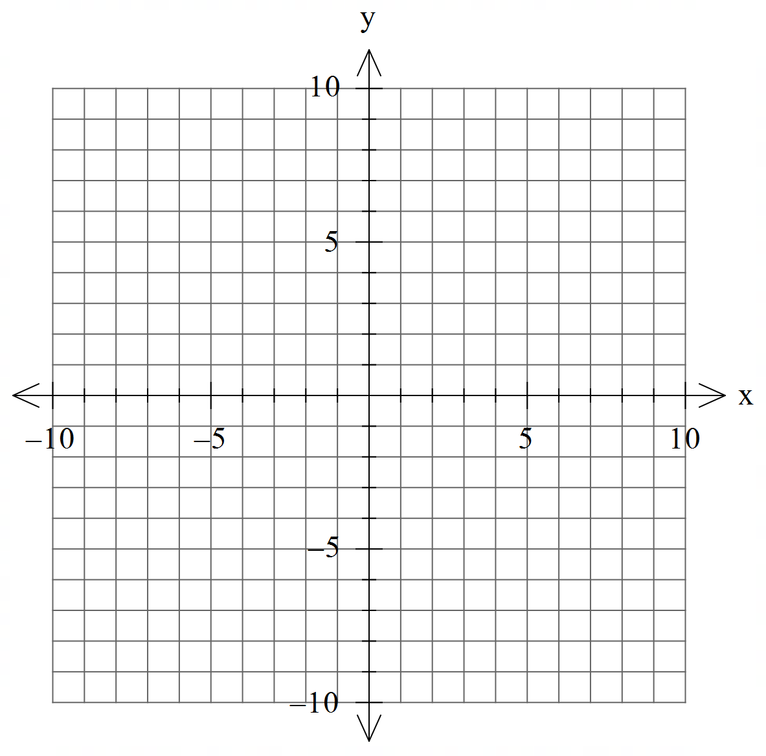

- Hence determine the natural domain and range of (3 marks)

Question 6 (6 marks)

Consider the linear equations

- Solve for . (3 marks)

- Consider the following system where are constants. (3 marks)
Solve for all possible values of for the following scenarios:
- Unique solution
- Infinite solutions
- No solutions.

Question 7 (10 marks)

Consider the function for which is plotted below.

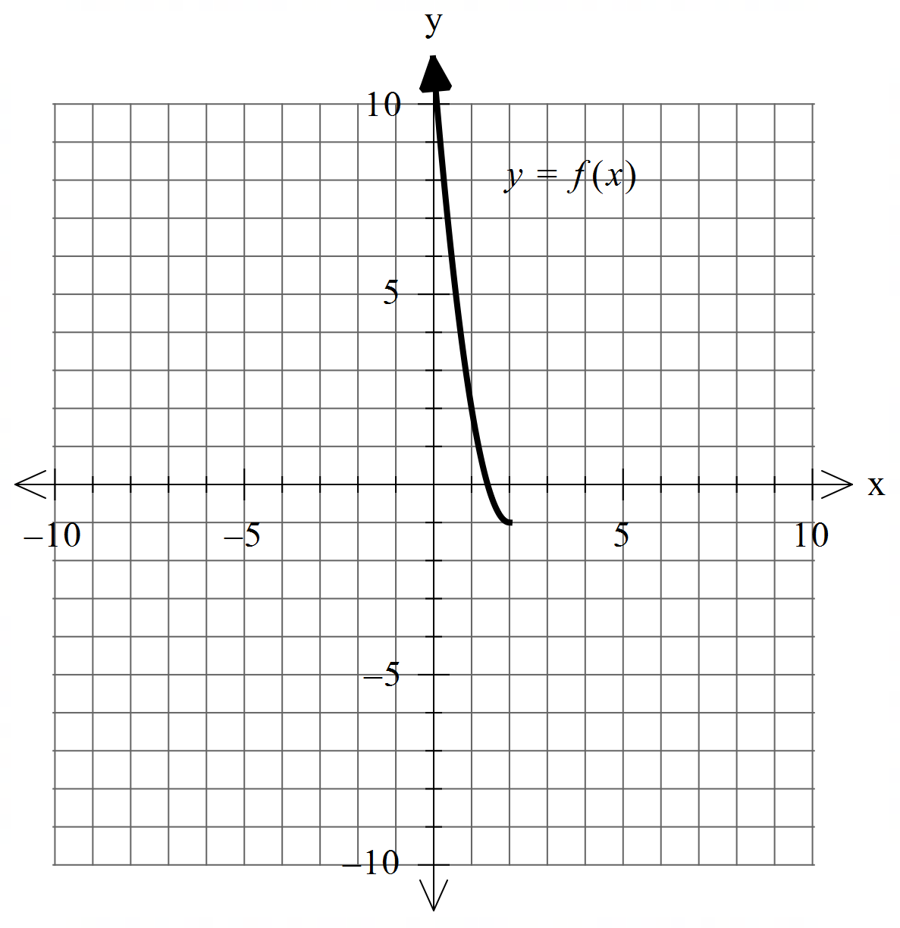

- Sketch the inverse function on the axes above. (2 marks)

- Determine the rule for and state its domain. (4 marks)

Q7 continued.

c) Determine (1 mark)

d) Determine the exact coordinates, if any, where (3 marks)

Question 8 (4 marks)

Consider two parallel planes . Plane is given by and plane contains the point .
Show that the distance between the two planes is given by

Additional working space
Question number:

